Case 0 : ----- when A = 0v ---- op is 5v

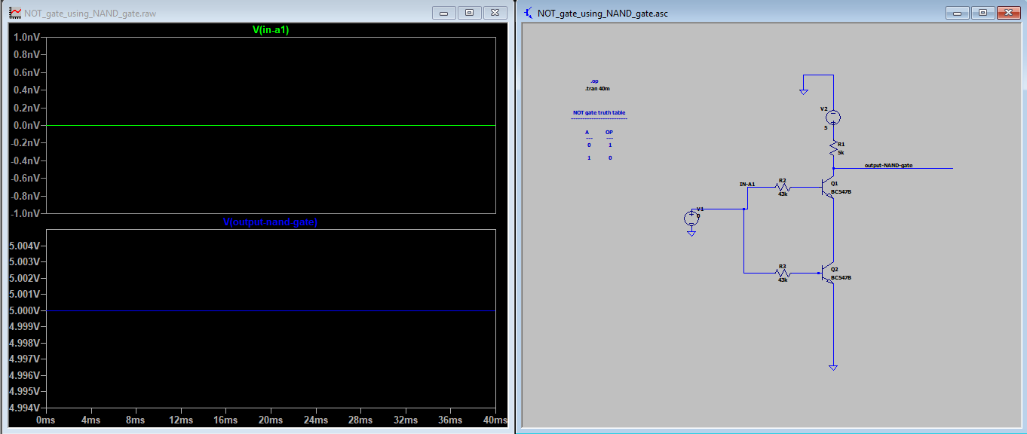

Case 1 : ----- when A = 5v ---- op is 0v

